Exercise 2 (2 pages)

It is important to define or select similarity measures in data analysis. However, there is no commonly- accepted subjective similarity measure. Results can vary depending on the similarity measures used. Nonetheless, seemingly different similarity measures may be equivalent after some transformation.

1. One of the methods to calculate the dissimilarity score for nominal attributes is simple matching. The equation of simple matching as follows:

$$d\left(i,j\right)= \frac{number of all attributes \left(p\right)-number of matching attribites (m)}{umber of all attributes \left(p\right)}$$

Examples are provided in D2L slides (slide 29).

Table 1 shows a set of video games and their nominal attributes. Please calculate the dissimilarity score between two pairs of data objects

* 1. d (Witcher 3, Mortal Kombat 11)
  2. d (any two games of your choosing)

Table 1: Games that Rule

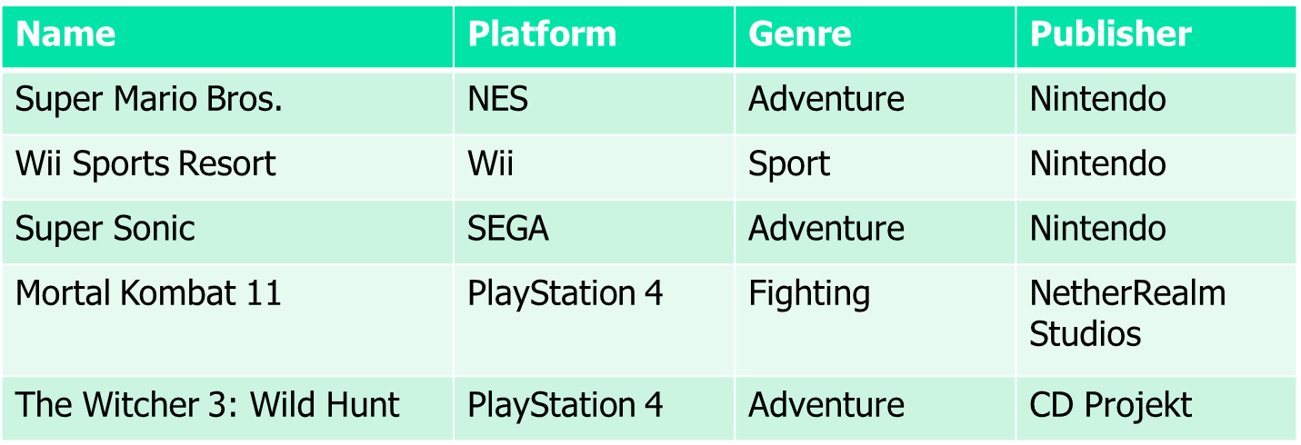

1. Calculate the dissimilarity score for binary attributes:

$$r= number of all attributes that equal 1 for i but 0 for j$$

$$s=number of all attributes that equal 0 for i but 1 for j$$

$$q=number of attributes that equal 1 for both i and j$$

$$d\left(i,j\right)= \frac{r+s}{q+r+s}$$

Examples are provided in D2L slides (slide 33).

1. Table 2 shows a set of fictional characters and their binary (asymmetric) attributes. Please calculate the dissimilarity between two pairs of data objects
   1. d (Cersei Lannister, Daenerys Targaryen)
   2. d (any two characters of your choosing)

Table 2: The faceless Table, a Table has no name

